We have a new domain to our world. The cyber domain. Like most new things, it isn’t safe until we create rules and ways to make sure that it is good for the users. In order to complete this, we need to find the bad people and take them to justice. Before all that, we need to protect the people. The best way to make sure they stay safe is to use MANY forms of media; like print flyers, digital flyers, commercials, cartoons, and social media like Facebook.

Cyber Safety is something that people are having tons of trouble with recently. We think the best way to inform people of the dangers is to create a flyer and put them up around towns and cities. This is a great way to get word out to people about the dangers of the cyber world. We shouldn’t sugar coat it so that they don’t understand the real life dangers that could happen to them. Notice that people are always saying that we don’t give them enough information, and that is sometimes true. We do not provide enough information, but, I believe this will give our users enough information to make sure that they are safe about their choices online.

There are many dangers online. One being social media. While it was created to meet new people or talk to old friends. A great example would be Facebook. A more current social media that asks for what you like, where you live, where you are from and so on. This is so that you can connect with people around you with common interests. Although, with that much information, it is easy for people to steal your identity. They have your picture, what you do, where you are; with what you like they could even find your bank. This is how they pretend to be like you and from there they could make your life a living hell.

A not-so-recent way of spreading things would be via television. Commercials, movies, T.V shows, YouTube, and the news are all ways of spreading what we know to the people. If you think about it, the average person watches at least 2 hours of video a day. This would be an ideal time to show them what is going on in the back scenes and could really help them in the long run. People of all ages watch videos, whether it’s on television or online, they still are exposed to it. Teachers could show the clips in class, to make sure that kids know that what they put online could do some serious harm.

With that, I’ll leave you to think about what you put online. Is it worth it to ‘connect’ with people to also put yourself at that risk, of having everything you have go down the drain? I sure hope not. I for one will always be cautious about what goes online. It could mean nothing to me, but everything to them.

**Student Created Propaganda Resources**

**1. Flyer:** Also connects to social media for easy sharing. (After you have scored the essay contact us for the link to the flyer- the web version includes an author name so we did not include it here. Screen shots without the author name are below)

**2. Hacked Facebook page** of President Obama. Link: <http://www.classtools.net/FB/1164-JinDdx>

**3. Student Created Cartoon Video** (Just realized our faces are in the video. After you grade the essay contact us to see the video to make sure we do not violate the naming your school rules)

* Screen shots of images below

Image 1 Flyer

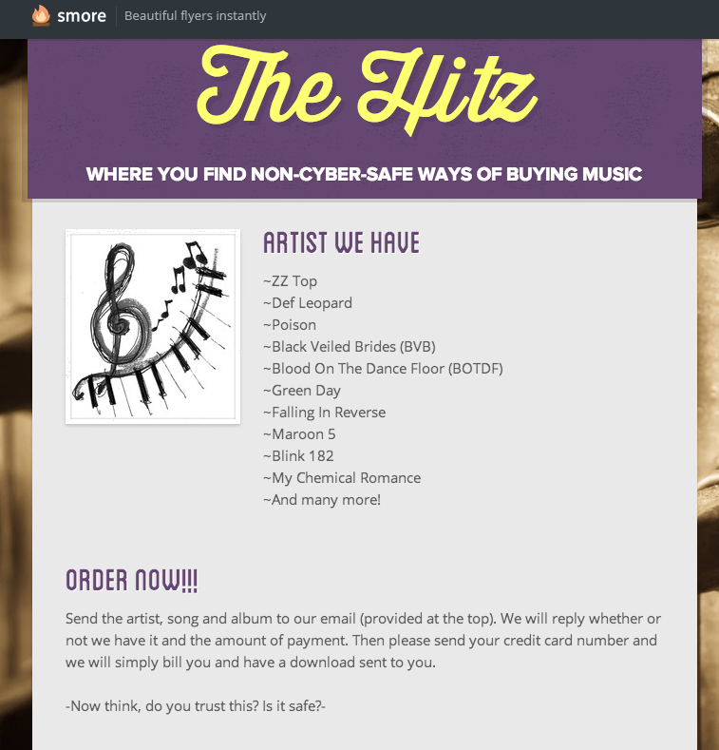

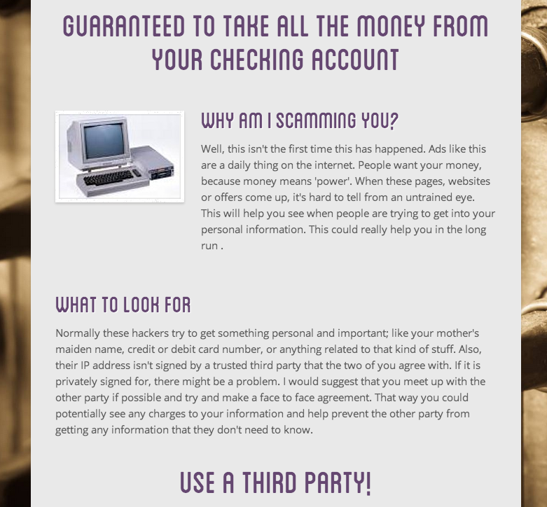

**Image 2 Hacked Facebook Page Screen**

